# Using the Relationship View

The relationship view allows you to view your risk event and its relationships with other risk elements.

On this page

* Relationship view
  + Calculations
  + Where does the data come from?

## Relationship view

The relationship view represents the risk event (1) as the middle element. The drivers (2) and preventive controls (3) are on the left side, and the consequences (5) and mitigating controls (4) are on the right side.

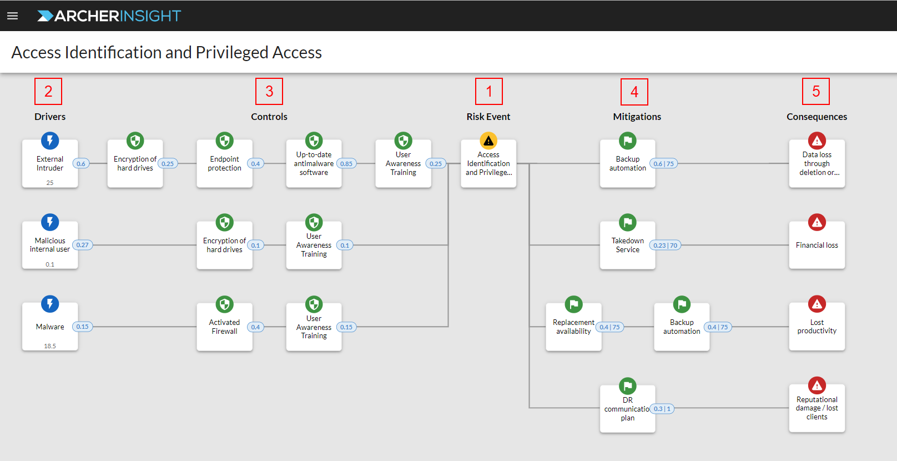

Preventive controls are placed between the driver and the risk event and represent controls that can decrease the probability that the risk occurs when the associated driver occurs.

Mitigating controls appear between the risk event and a consequence and represent controls that can decrease the impact of the consequence when the risk occurs.

### Calculations

The following table describes the individual calculations in the relationship view.

| Element | Image | Description |
| --- | --- | --- |
| Driver rate | Driver frequency | How often the driver occurs annually. |
| Driver-to-risk probability | Driver-to-risk probability | If the driver occurs, the probability that the risk will occur. |
| Preventive control probability of success | Control probability of success | If the driver occurs, the probability that this control prevents the risk event from happening. In the control, you can view the actual probability of success, which is calculated based on the Compliance and Lifecycle statuses. |
| Mitigating control probability of success | Mitigation probability of success | If the risk event occurs, the probability that this control reduces the impact of the consequence. |
| Impact reduction | Impact reduction | For financial controls, the reduction in financial impact due to the mitigating control. |
| Number of levels reduction | New impact category | For non-financial controls, the number of impact levels reduced by the mitigating control. Always an integer. |

### Where does the data come from?

The following table describes each element and its source in Archer.

| Element | Source |
| --- | --- |
| Risk Event Name | Insight Risk Event application > Risk Event Name field |
| Driver Name | Insight Drivers application > Name field |
| Driver Rate | Insight Drivers application > Rate field |
| Driver-to-Risk Probability | Insight Driver Probability application > Risk Probability |
| Preventive Control Name | Control Procedures application > Procedure Name field |
| Probability of Success | Insight Control Probability application > Probability of Success field |
| Compliance | Control Procedures application > Compliance field |
| Mitigating Control Name | Control Procedures application > Procedure Name field |
| Probability of Success | Insight Control Probability application > Probability of Success field |
| Impact Reduction | Insight Control Probability application > Impact Reduction field  **Note:** This field only applies when the consequence is financial. |
| Number of Levels of Reduction | Insight Control Probability application > Non-Financial Number of Levels of Reduction field  **Note:** This field only applies when the consequence is non- financial. |
| Consequence Name | Insight Consequences application > Name field |